AWS Technical Essentials Project – Server Monitoring
Description
Heaven Classics successfully creates an EC2 Server Instance for Windows 2012 Server. After launching the instance on the server, the next step was to monitor the operations.
Monitoring is important to keep an eye on the performance of an EC2 instance. It helps gather data from all parts and is useful for debugging failure.
The monitoring team at Heaven Classics started monitoring activities using the CloudWatch Service in the AWS Management Console. The Heaven Classics support team were required to meet the following objectives:
Steps to Perform:
- Check and observe the CPU utilization graph for the EC2 instance
- Create and configure a CloudWatch alarm that sends an email notification to HCMonitor@HeavenClassics.com if the CPU utilization goes below the threshold of 3%, consecutively three times for five minutes
- Create an IAM group named Administrator Group and attach the full administrator access policy to the group
- Create a user for an employee of the company who requires administrator access to the company's AWS account, and then add the user to the Administrator Group.

First set up New EC2 Instance to monitor
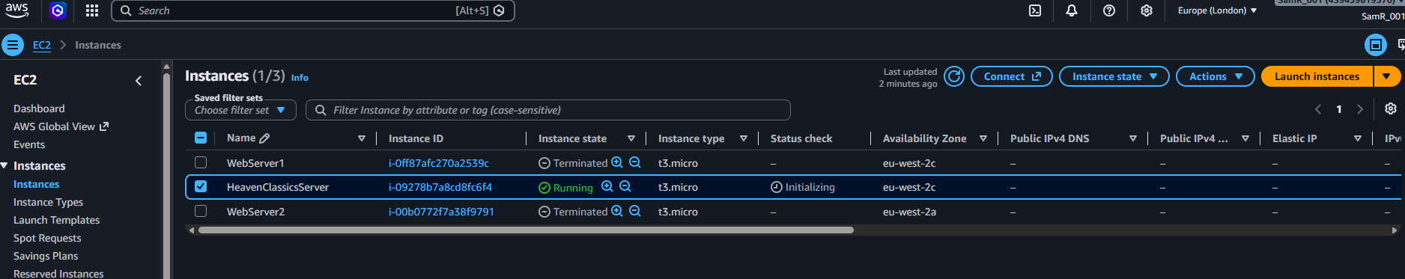

Step 1 – Check and observe the CPU utilization graph
What is happening: Every EC2 instance automatically sends performance data to CloudWatch without anything being installed. The CPU utilization graph shows how hard the instance's processor is working over time, which is the baseline to use to decide what an abnormal reading looks like.
CPU utilization graph bottom left for server below.
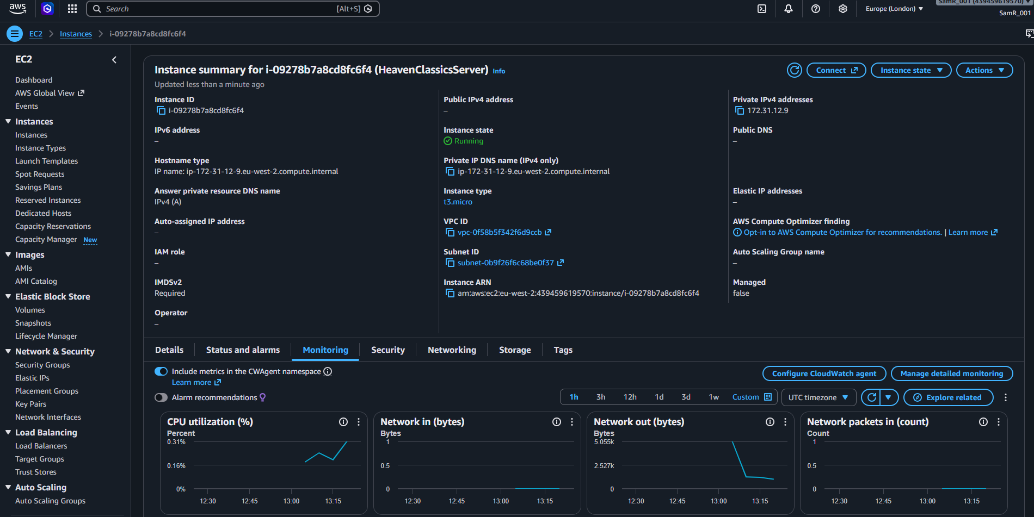

Step 2 – Create and configure the CloudWatch alarm
What is happening: A CloudWatch alarm watches a metric and changes state when the metric crosses a threshold you set. Here the alarm watches CPU utilization and moves into the In alarm state when the average CPU stays below 3% for three consecutive five-minute periods, then publishes a notification through SNS so the support team is told about it.
Create the alarm
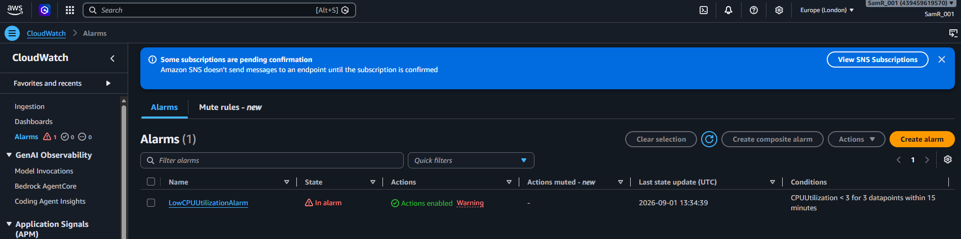
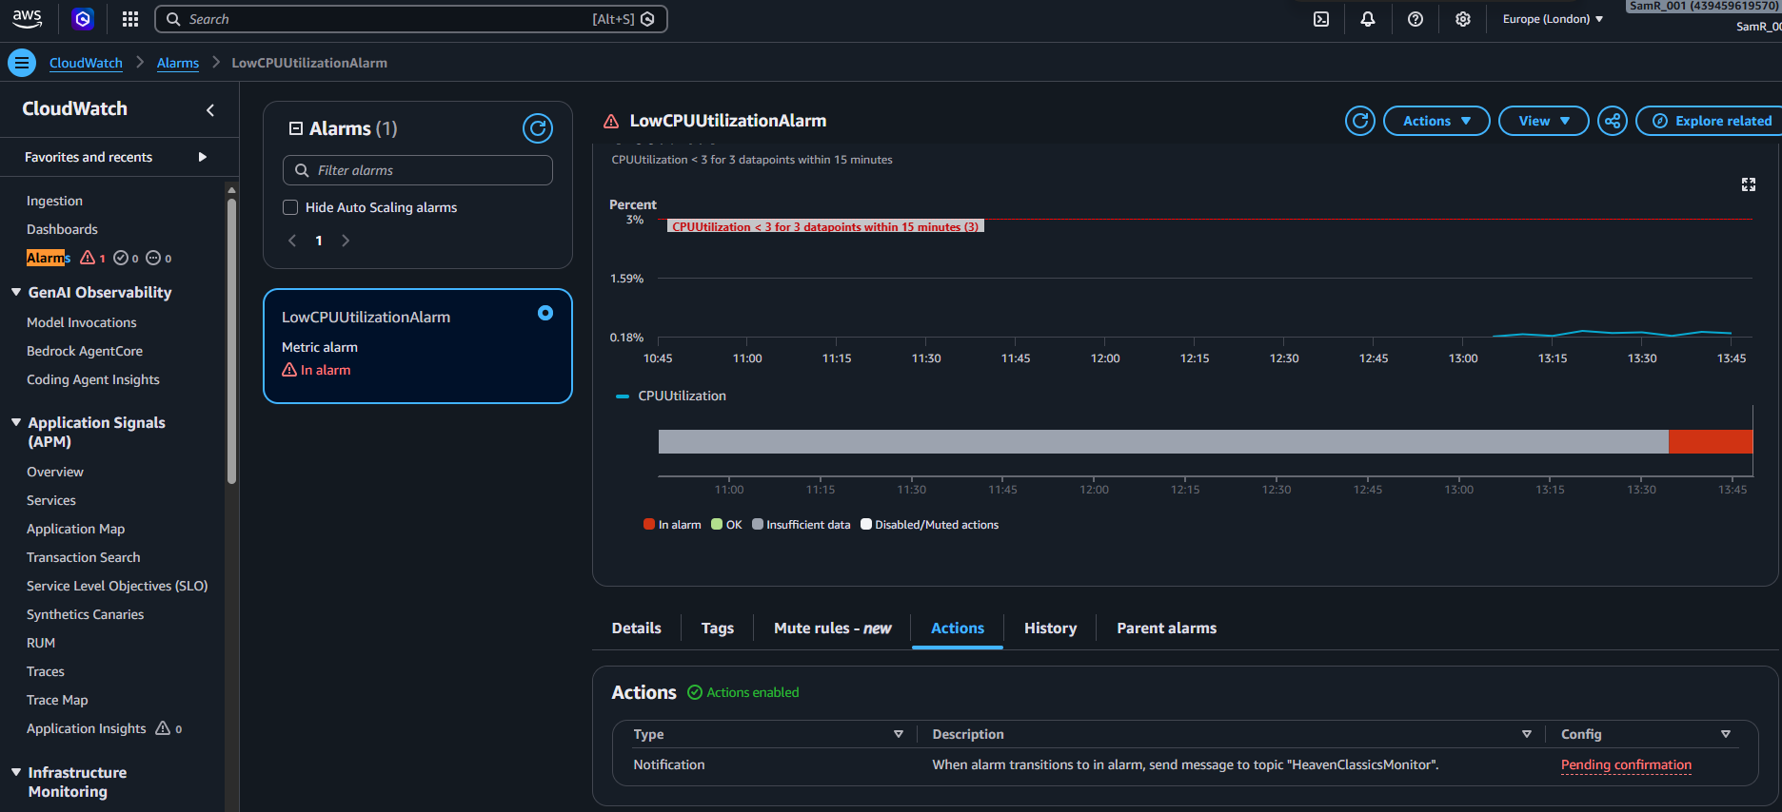
Step 3 – Create the IAM group and attach administrator access
What is happening: An IAM group is a container for users that carries a set of permissions. Attaching the AdministratorAccess policy to the group means every user placed inside it inherits full administrator rights, so permissions are managed once on the group rather than repeatedly on each person.
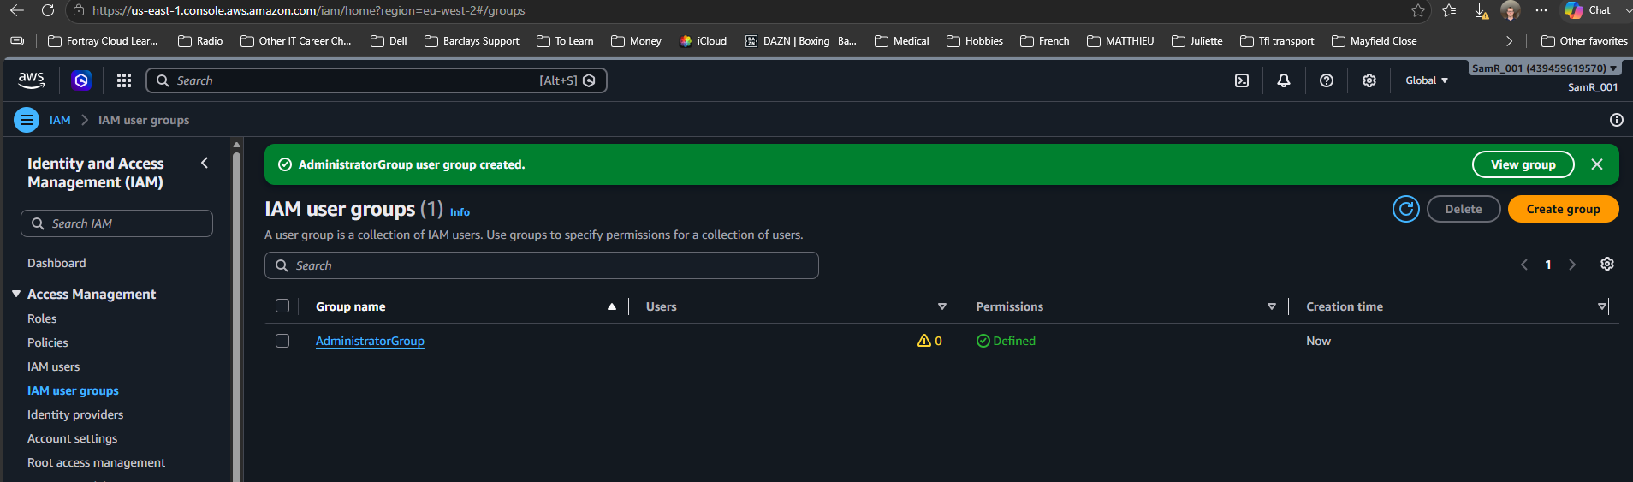

Step 4 – Create the user and add them to the group
What is happening: The employee needs their own identity in the AWS account rather than sharing the root login. Creating an IAM user and placing them in the administrator group gives them exactly the access they need, and it can be revoked later by removing them from the group.
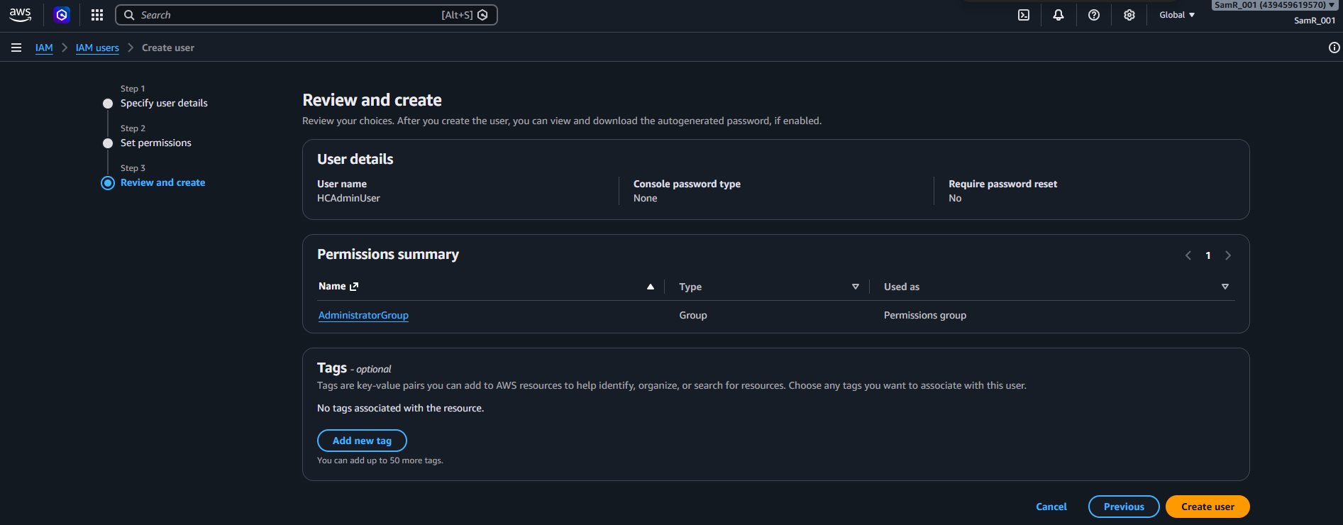
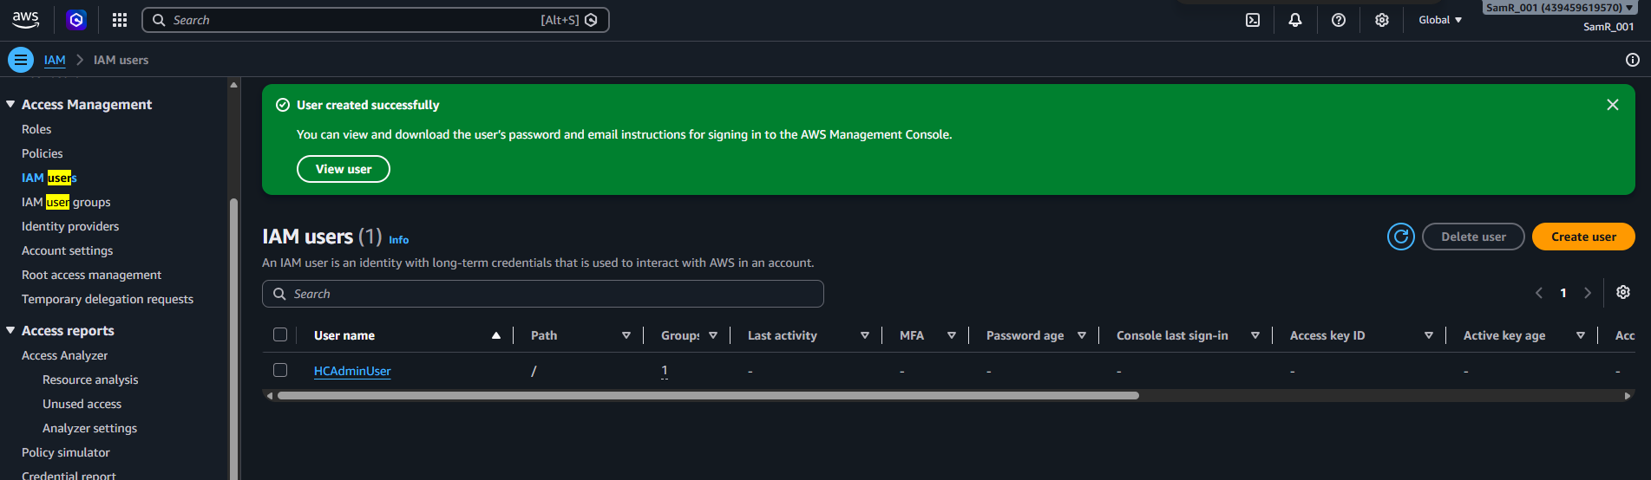

Additional:
SNS Subscriptions
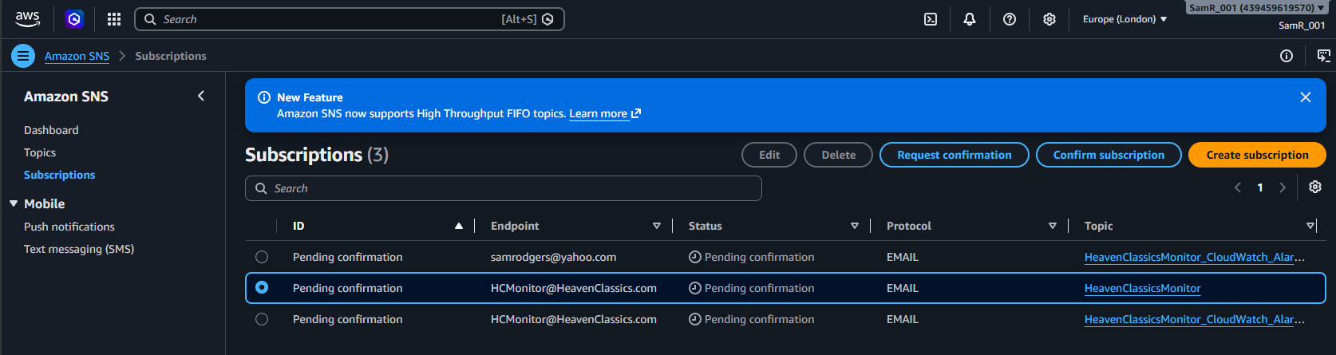

SNS Topics
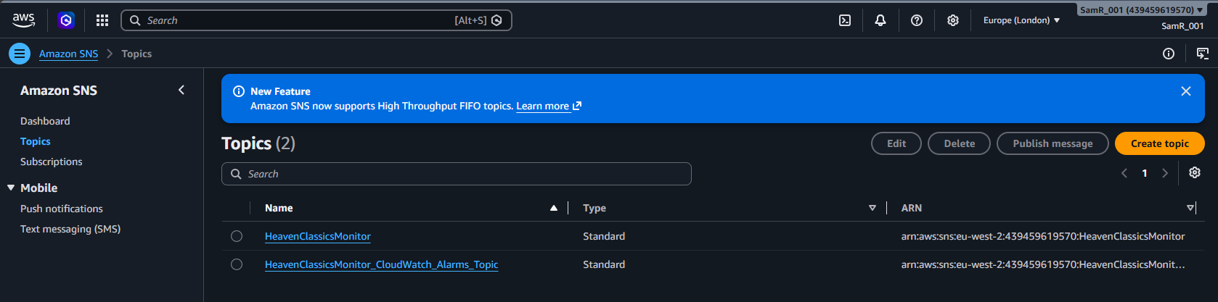
Added more than once as didn’t reeive email

